Certified Lean Practitioners
- Demonstrate a clear understanding of the Lean practitioner body of knowledge: lean culture, principles, and playbook.
- Tactically solve problems and implement lean improvements within a work cell, work group, and/or value stream.
- Achieve measurable results for their organizations.
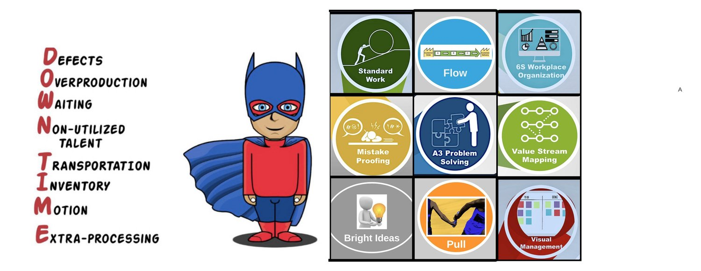

Lean Practitioner Certification Components

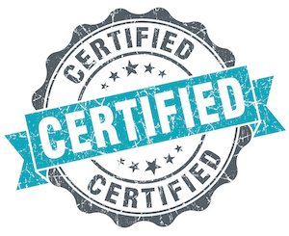
- 27-hours of active, in-person classroom instruction from experienced Lean leaders.
- Applicable case studies, guest speakers, and hands-on learning exercises.
- 6-hours of one-on-one coaching sessions and multiple site visits/Gemba walks at each participant’s facility.
- Tailored homework assignments on the Lean principles and playbook: 8 wastes, 6S workplace organization, standard work, visual management, value stream mapping, and A3 problem solving.
- Access to on-line course portal with all course materials and LeanJax’s standard work library (videos, templates, instructions, examples, etc.
- Open-note Lean practitioner certification examination.
- Value Stream Mapping/A3 certification project and report-out presentation.
- Collaboration opportunities with fellow attendees.

Cost
Participants from LeanJax Member Companies

$2,000

Participants from Non-LeanJax Member Companies

$2,500

Benefits for Participants

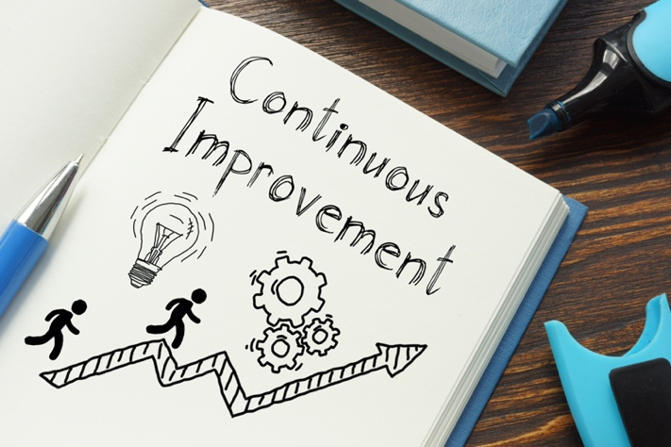
- Receive certification as a Lean practitioner, a highly respected credential that promotes career advancement.
- Gain the requisite Lean knowledge and skills to drive tangible improvements in your organization.
- Lean how to maximize customer value, eliminate waste, improve key processes, solve problems, and achieve compelling results.
- Receive helpful resources, tailored coaching, and continuous feedback from experienced Lean practitioners.
- Begin development as Lean improvement event leaders and organizational change agents.

Benefits for Organizations
- Improve key work processes that will generate compelling results in productivity, cost, delivery, quality, customer satisfaction, and safety.
- Provide participants with the knowledge and skills needed to solve problems and continuously improve their work.
- Share and spread continuous improvement and problem -olving capabilities throughout your enterprise.
- Receive robust ROI by having participants complete impactful projects aligned with your organization’s goals.
- Gain the internal capability to successfully launch or accelerate your organization’s Lean journey.
Training Schedule
- All training sessions will be conducted live in Jacksonville Florida at a TBD location. Each in-person course runs for four (4) hours; the Zoom kickoff is only 60 minutes.

The courses are held once every two weeks.

The project report-outs and graduation ceremony will be conducted at each attendee’s facility.

Courses

- Kickoff Zoom Meeting for Students and their Supervisors
- Introduction to Lean
- Eliminating the 8 Wastes
- 6S Workplace Organization
- Visual Management Systems and Error Proofing
- Value Stream Mapping
- A3 Problem Solving
- Project Report outs and Graduation Ceremony

Past Attendees

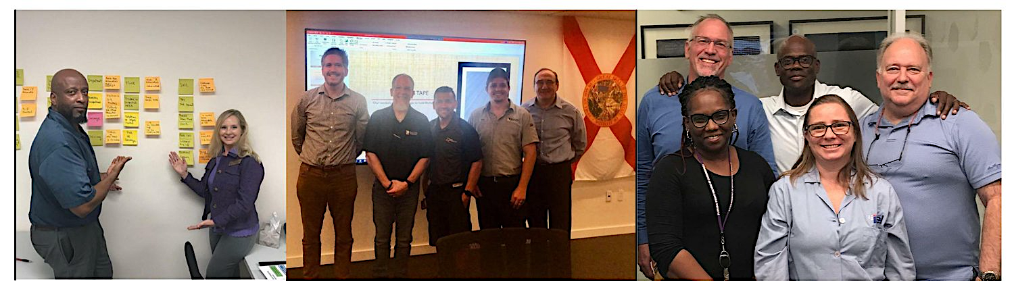

Our Lean practitioner certification courses have included attendees from the following companies:

- The Arc Nassau
- BAE Systems
- Barnabas
- Coastal Shower Doors
- Commercial Metals Company
- Clay County Sheriff’s Office
- Fincantieri Marine Systems
- ITEL Labs
- Johnson & Johnson
- Medtronic
- Pilot Pen
- Q-PAC
- Rulon International
- Safariland
- Seal Shield
- Soler & Palau Ventilation Systems
- TIAA Bank
- US Gypsum
- Veritec Solutions
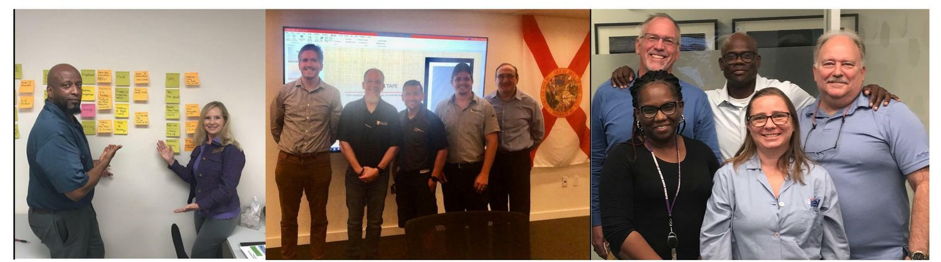

Testimonials

“I’ve received Lean training before, but wanted to let you know that this program is the most informative Lean training I’ve ever participated in. The training has helped me make sustainable improvements to my processes as a warehouse manager.”

This training is a great opportunity! I highly recommend it! I learned so much from the instructors and my classmates. It will change your organization for the better.”

“Thank you for a great class! Lean Thinking’s “blame the process, not the people” mindset resonates with me. I learned a lot from this training. One of my biggest takeaways was the importance of “going to the Gemba” to show the employees that you care about them and their work, while also enabling them to contribute and grow.”

“This training has helped me think of many ways on how to improve things. I really enjoyed the instructor’s style and how he blended Lean concepts with real-world examples.”

For More Information

- Please reach out to the training series instructor, James Bussell, at (904) 742-2547 and james@leanjax.org for more information on how you or your employees can benefit from participating in this training series.
- For more information on the Jacksonville Lean Consortium, please visit www.leanjax.org.

