Lean Awareness Training Overview

Duration: 90 minutes
Purpose: Provide Lean Thinking awareness to our member organizations’ team members.

- Introductions
- Concise history of Lean Thinking
- Lean benefits and case studies
- Definition and 5 Lean principles

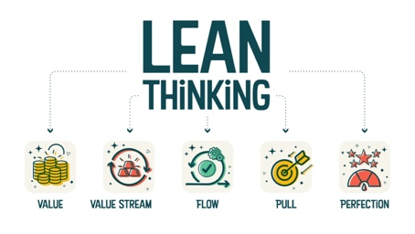
- Overview of Lean culture and behaviors
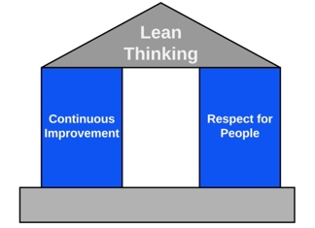

- Overview of Lean playbook
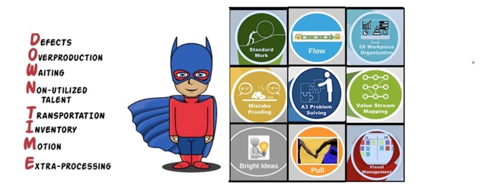
- Standard pig exercise
- Lean practitioner and facilitator certifications
- How to begin applying Lean

- Q/A

